# Lab_01

|  |  |  |
| --- | --- | --- |
| 202283890036 | 黄家睿( Jerry Huang) | IOT major |

目录

Lab_01 1

1. Installing a virtual machine. 2

1.1.1. 2

1.1.2. 2

1.1.3. Running Ubuntu in VMware Workstation 3

2. Character Interface Operation Basics 4

2.1. ls 4

2.2. cd 4

2.3. pwd 4

2.4. Touch 4

2.5. rm 5

2.6. mv 5

2.7. mkdir 6

2.8. cat 6

2.9. cp 7

2.10. Shotdown now 7

# Installing a virtual machine.

### 

download ubuntu from internet then store in a identify place where you can find it.

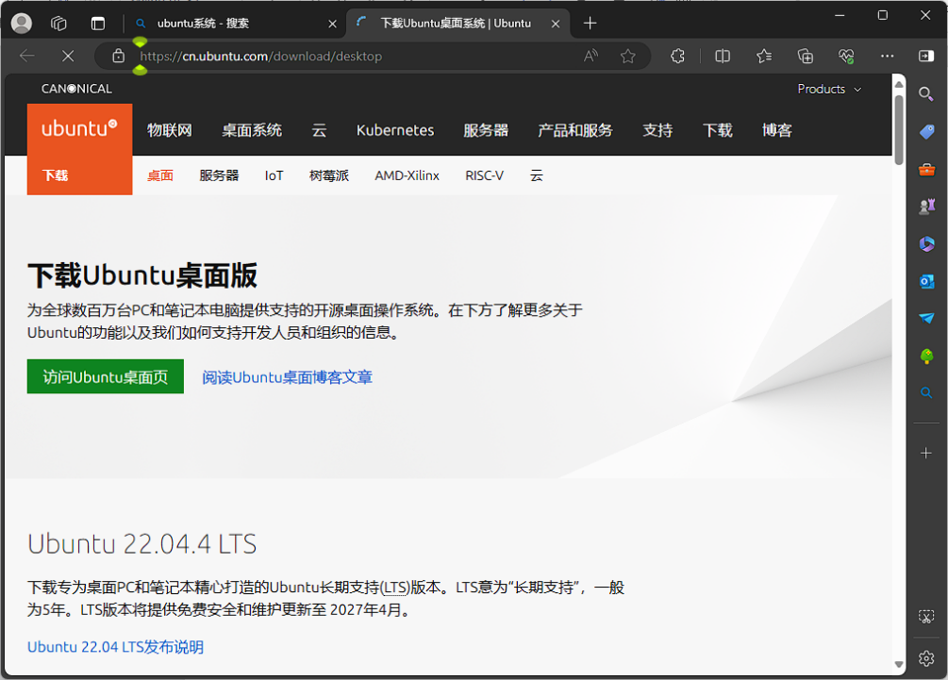

### 

Install Virtual machine vmware workstation.

Click the download for windows.

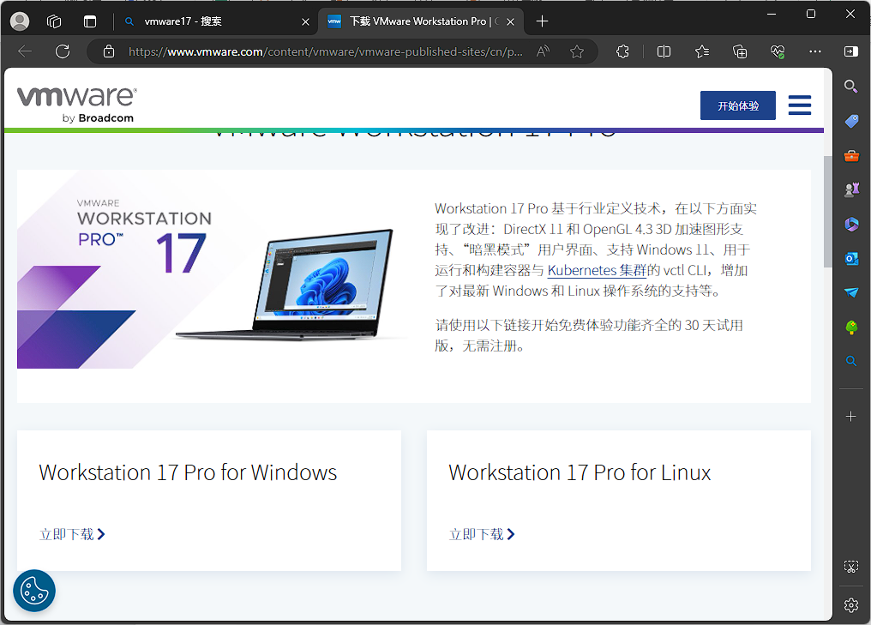

### Running Ubuntu in VMware Workstation

